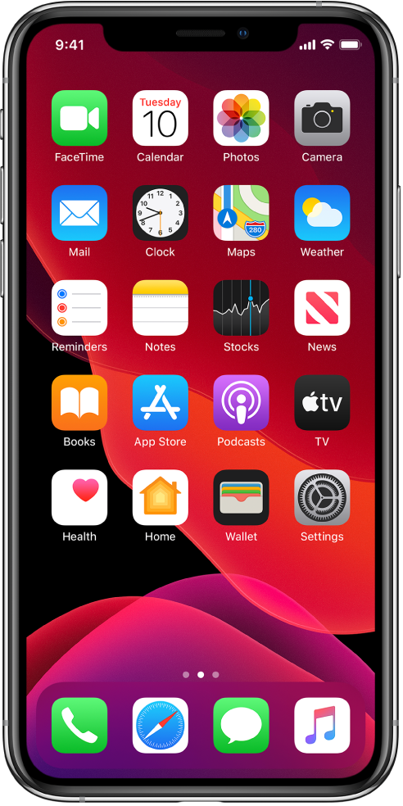

iPhone iOS 13 User Guide

Brandon Lau

**Table of Contents**

Getting Started 3

What’s New in iOS 13 3

**Dark Mode** 3

**Maps** 4

**Siri** 5

**Reminders App Updated** 5

Supported iPhone models 5

# Getting Started

This iPhone iOS 13 User Guide will direct you through setting up your iPhone and let you know about the different features that are available in your device, as well as some features that were introduced or changed in the previous iOS 13 update.

## **What’s New in iOS 13**

### **Dark Mode**

A new Dark Mode option gives the entire iOS experience a beautiful dark color scheme that is perfect for low-light environments. You can set Dark Mode to turn on automatically at a certain time by going to Settings > Displays & Brightness and select Automatic. Tap Options to set an automated schedule for Dark Mode.

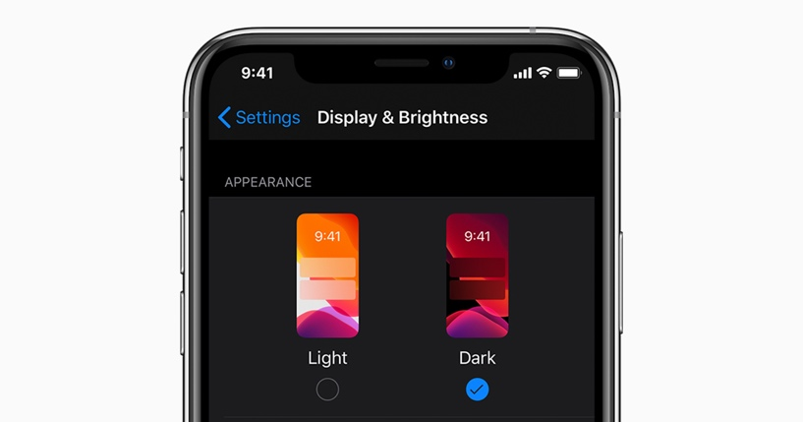

**Photos**

The new Photos app allows you to see your photos based on days, months, and years so it’s much easier to find and share your photos and videos. As you scroll through, Live Photos and videos play, bringing life and energy to your photo library. Redesigned editing tools in the app also make it easy for you to apply changes to your photos and to get a glance at what changes were made.

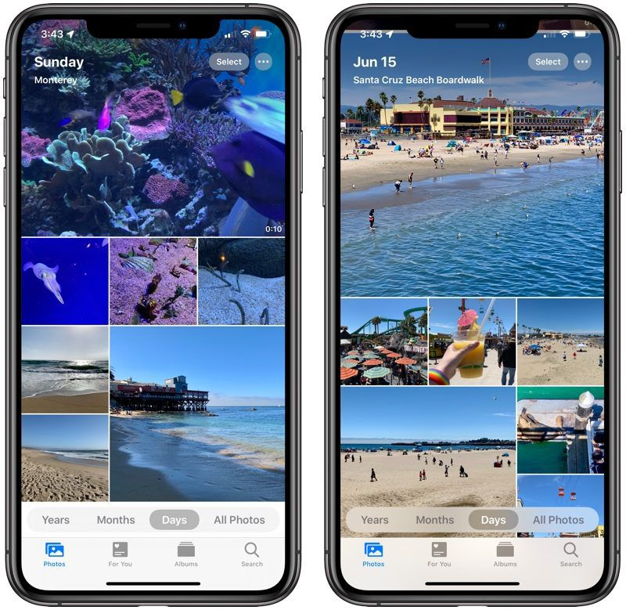

### **Maps**

Having undergone a complete change in design, Maps now has more realistic details for roads, beaches, parks, and buildings. Be sure to explore where you’re going before you get there with Look Around in Maps, build collections of your favorite locations, and share your ETA. See [Use Maps on your iPhone, iPad, or iPod Touch](https://support.apple.com/en-us/HT202570) for more.

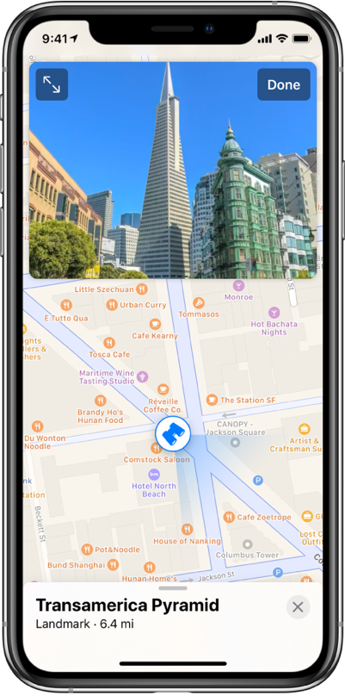

### **Siri**

The new Siri voice sounds incredibly natural, especially when speaking longer voices. Siri now also offers personalized suggestions when you search in Podcasts, Safari, and Maps, and can detect reminders in Messages. See [Ask Siri](https://support.apple.com/guide/iphone/ask-siri-iph83aad8922/ios) for more.

### **Reminders App Updated**

The all-new Reminders App now makes it easier than ever to organize and create reminders. You can use the quick toolbar to add times, dates, locations, flags, photos, and even scanned documents to your documents. See [Set reminders](https://support.apple.com/guide/iphone/set-reminders-iph88463e18/ios).

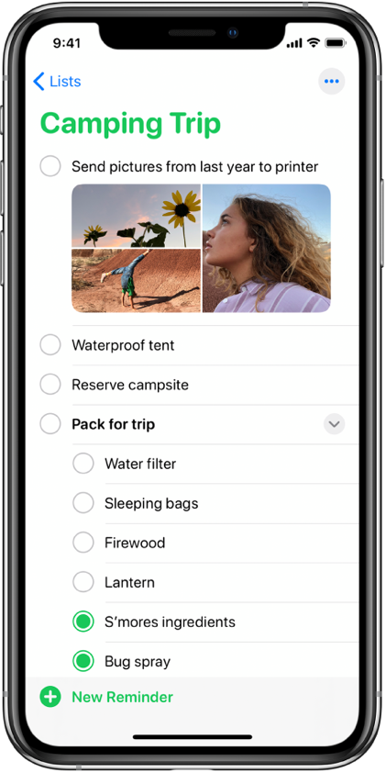

# Supported iPhone models

This is a guide that will help you get started on setting up your iPhone and discovering the amazing things that it can do on iOS 13.

Here is a list of the following iPhone models that support iOS 13:

* iPhone SE (2nd Generation)
* iPhone 8
* iPhone 8 Plus
* iPhone 7
* iPhone 7 Plus
* iPhone 6s
* iPhone 6s Plus
* iPhone SE (1st Generation)
* iPhone 11
* iPhone 11 Pro
* iPhone 11 Pro Max
* iPhone XR
* iPhone XS
* iPhone XS Max
* iPhone X

**Index**

Automatic ***3***

Dark Mode ***3***

design ***4***

Maps ***2***, ***4***, ***5***

Messages ***5***

Options ***3***

photos 5

Podcasts ***5***

Reminders ***5***

Settings ***3***

Siri ***5***

suggestions ***5***

times ***5***

videos ***3***